# Understanding the interpretations of Machine Learning

Notebook by Reece Turner, 22036698.

Table of Contents

**Type chapter title (level 1)1**

Type chapter title (level 2)2

Type chapter title (level 3)3

**Type chapter title (level 1)4**

Type chapter title (level 2)5

Type chapter title (level 3)6

# Fundamentals of Machine Learning

## Types of Machine Learning:

**Supervised Learning**: The algorithm learns from labelled data, with inputs paired with corresponding target outputs. The aim is to learn a mapping from inputs to outputs.

**Unsupervised Learning**: The algorithm learns from unlabelled data, finding hidden patterns or structures within the data.

**Reinforcement Learning**: The algorithm learns to make decisions by interacting with an environment, aiming to maximize some notion of cumulative reward.

### Supervised Learning

An example of a supervised learning algorithm is Support Vector Machines (SVM). It is a classification learning model which takes an existing dataset and splits it into training data (X_train, y_train) and testing data (X_test, y_test).

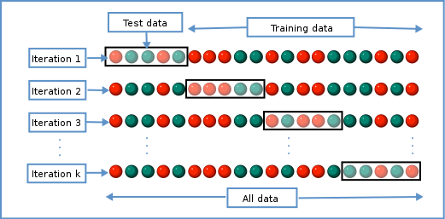

To know if it is a supervised learning model, the algorithm would require an existing dataset then take a **test size** of the data which becomes the test data and the rest becomes training data.

the algorithm would be tested on a classification, **C=1.0**, where the hyperparameters are considered ‘best-fit’ (not be to be confused with best-fitness)

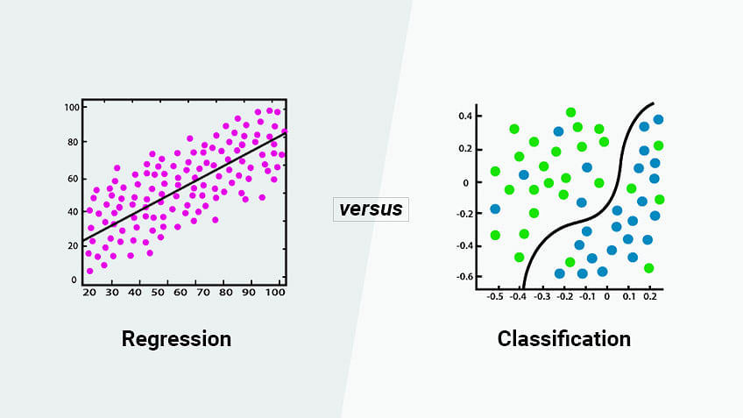

Here is an example of regression and classification. While both decision boundaries are calculated differently, they are both in fact supervised learning.

## Data Preparation:

**Data Collection**: Gathering relevant data from various sources.

**Data Cleaning**: Removing or correcting errors, dealing with missing values, and ensuring data consistency.

**Data Preprocessing**: Transforming data into a suitable format for machine learning algorithms, including feature scaling, normalization, and encoding categorical variables.

## Model Selection and Training:

**Choosing an appropriate model**: Depending on the problem, different algorithms (such as decision trees, neural networks, support vector machines) may be suitable.

**Training the model**: Feeding the algorithm with the prepared data to adjust its internal parameters to minimize errors or improve performance.

## Model Evaluation:

**Testing the model**: Evaluating the trained model's performance on unseen data (validation set or test set) to assess its generalization ability.

**Metrics**: Using various evaluation metrics such as accuracy, precision, recall, F1 score, or area under the curve (AUC) depending on the problem type (classification, regression, etc.).

## Continuous Learning:

Machine learning is an iterative process. Models may need to be updated or retrained as new data becomes available or as the problem domain evolves.